Ervin Sarmiento

Probability and Applied Statistics

Piece 1 Final Project Report

This report formally introduces my chosen topic of interest while using the class book, Mathematical Statistics With Applications 7th Edition, called 1999-2017 Accident Deaths (Unintentional Injuries) as a means to express the dataset as a problem solver for the book. The dataset highlights accidents that dates back to the 1999 up to 2017 where deaths is caused by unintentional means. This data was extracted from a set of data that was originally created to include all types of death causes such as intentional injuries, health related death, and more but for the purpose of this project, I only included unintentional injuries. All 50 states are included, each with each own deaths recorded every year and also include Age-adjusted Death Rate. Each chapter, starting from chapter 1, was selected with each section being carefully selected for a problem that can be used to implement my data set. Solving the problem of each section on each chapter was tedious but was a great learning experience on top of the research that was done. It gave me a different perspective on looking on the problem and applying my own logical thinking in order to solve a specific problem. It helped me do some critical thinking and creativity in order to create a visualized realization of the dataset implemented to the book problems. I have not done this type of project before therefore the entire step of the way was a learning experience. From creativity to doing formal reports, everything was new. It’s a good learning experience that I can apply to my future job in which reporting data and professionally creating documentation is important and this experience has certainly taught me this.

*Figure 1. Front page of my Dataset Report*

This report also formally introduces the updated equations formula that was remaining after creating the first formula from midterms. In the updated equations formula, we introduce that Uniform Distribution, Bivariate, Marginal Probability Function, Conditional Probability Function, Independent Random Variables. This formula sheet concludes the formula sheet that was created since Chapter 1 of the book up to half Chapter 5.

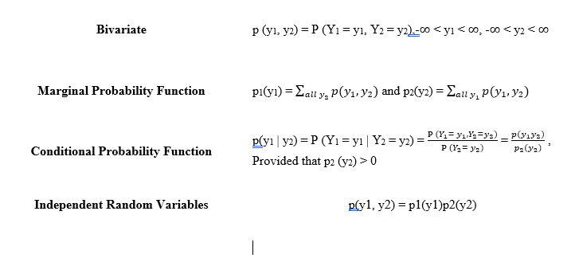

*figure 2. Screenshot of the final equations added to the equation formula sheet uploaded*